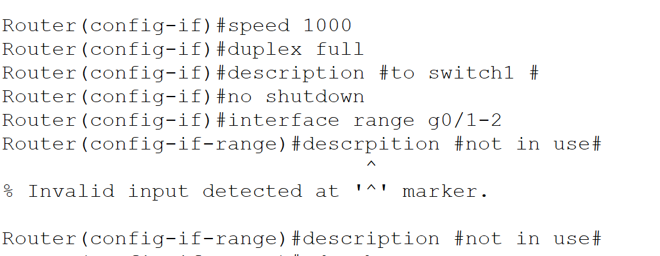
The image above shows commands that are used to set the speed of interfaces and set a range of the devices not in use.
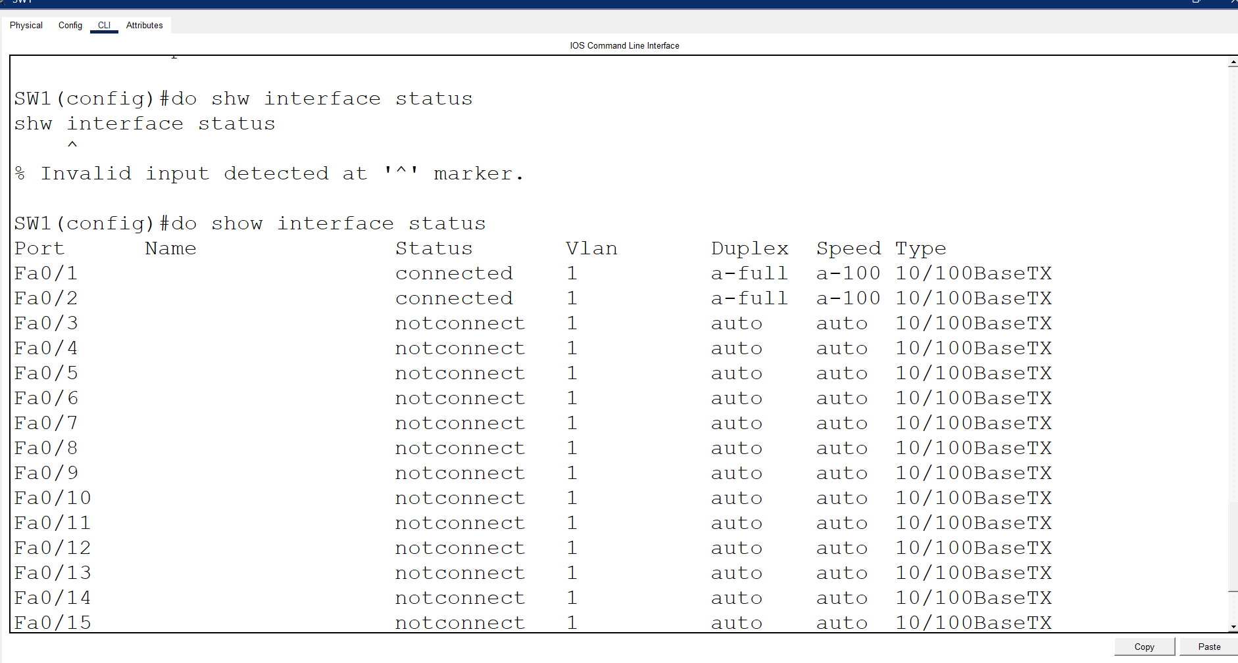
The image above shows the command that works with switches, to see the status of the switches.
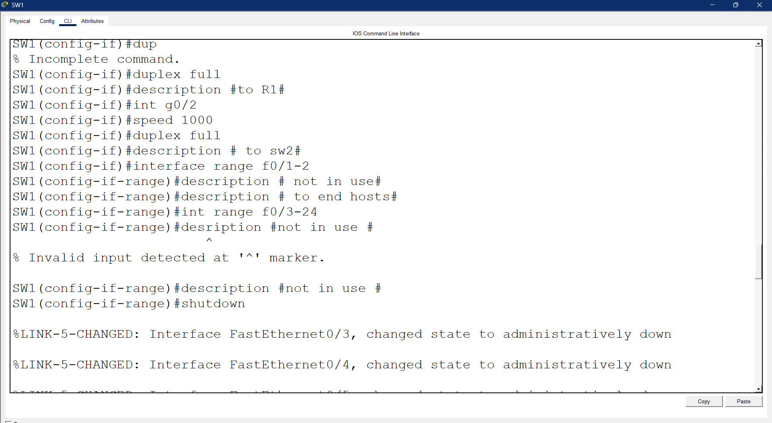
The above image shows commands where a range of interfaces from f0/3 to f0/24 being shut down since they are not being used

